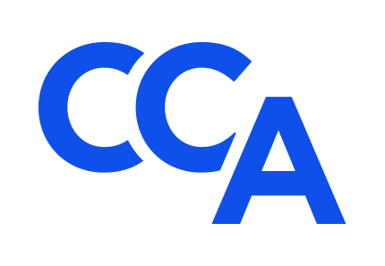
College of Commercial Arbitrators
Application for CCA Associates Program
Submission Deadline: August 5, 2022

Applicant
Name:
Employer:
Occupation: Title:
Address:
Phone: Email:

Please submit the following to highlight your qualifications for the CCA Associates Program as outlined in the accompanying Invitation: (1) a concise letter from you to the CCA Standing Committee on Diversity, which explains (a) your reasons for participating in the CCA Associates Program, (b) how you intend to develop the skills needed to distinguish yourself in the field of commercial arbitration; and (3) a concise resume of your education, training, and experience demonstrating the likelihood of your future success as a commercial arbitrator. Qualified non-attorneys are welcome to apply for admission to the program.
Two (2) letters of recommendation in support of this application from ADR professionals with personal knowledge of your character, talents, professionalism, and career goals would be much appreciated.
Schedule of Events
Associate and Mentor Selection Announcement: August 22, 2022.
Initial Virtual Meeting of Associates and Mentors: August 29 - September 2, 2022.
Second Virtual Meeting of Associates and Mentors: September 19 - 30, 2022.
CCA’s 22nd Annual Meeting: October 14-15, 2022. Fellows and Associates only at The Westin Kierland Resort in Scottsdale, AZ. Fellows and Associates may have one guest.
CCA’s 23rd Annual Meeting: October 2023. Details to follow.

Fellows, Mentors, and Associates will communicate regularly between annual meetings via committee meetings, CCA’s listserv, and other means, and collaborate informally throughout the year with the view towards sharing professional experiences and ideas in a collegial manner that encourages and promotes rewarding careers in the field of commercial arbitration.
Application Submission
Complete application packets (including all required materials) must be submitted electronically, on or before the submission deadline of August 5, 2022 at 5:00 p.m. MDT, to the Co-Chair of the Associates Program Subcommittee, L. Tyrone Holt, at Ty.Holt@holtllc.com, with a cc copy to: Bill Seward, College of Commercial Arbitrators, info@ccarbitrators.org. Telephone: (512) 372-8350.
Affirmation
Applicant affirms that (A) all information submitted in support of your application is true and accurate to the best of your knowledge, information, and belief; (B) you are ready, willing, and able to attend CCA’s 22nd and 23rd Annual Meetings in person (via the Tuition Waiver described in the accompanying Invitation) and actively participate in the other upcoming Associate Program events throughout the two-year CCA Associates Program; (C) you are not currently and have not previously been the subject of a professional disciplinary proceeding of any sort; (D) it is your responsibility to promptly notify CCA and your Mentor in the event any of these circumstances change during your participation in the program.

Signature: Date:

