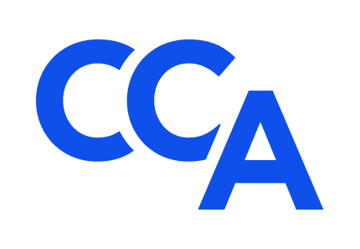
College of Commercial Arbitrators
Application for 2023-2024 Associates Program
Submission Deadline: March 24, 2023
Applicant
Name: ______________________________________________________________________
Employer: ___________________________________________________________________
Occupation: _________________________________ Title: __________________________
Address: ____________________________________________________________________
Email: ______________________________________ Phone: ________________________

Please submit the following to highlight your qualifications for the CCA Associates Program as outlined in the accompanying Invitation: (1) a concise letter from you to the CCA Standing Committee on Diversity, which explains (a) nature and extent of your prior experience serving as an arbitrator in domestic and/or international proceedings, (b) your reasons for applying or reapplying to participate in the program, and (c) how you intend to develop the skills needed to distinguish yourself in the field of commercial arbitration; and (2) a concise resume of your education, training, and experience demonstrating your qualifications for the program and the likelihood of your future success as a commercial arbitrator. Qualified non-attorneys are welcome to participate in the program.
Two letters of recommendation in support of this application from ADR professionals with personal knowledge of your character, talents, professionalism, and career goals would be much appreciated.
Schedule of Events
Application Submission Deadline: March 24, 2023.
Applicant Interviews: April 3 & 4, 2023.
Associate Selection Announcement: May 15, 2023.
Mentor Selection Announcement: June 15, 2023.
Initial Virtual Meeting of Associates and Mentors: September 11 – 15, 2023 (TBD).
Second Virtual Meeting of Associates and Mentors: October 9 – 13, 2023 (TBD).
CCA’s 23rd Annual Meeting: October 26-28, 2023. Fellows and Associates only at the Park Hyatt Hotel in Washington, D.C.
CCA’s 24th Annual Meeting: October 2024. Details to follow.
Fellows, Mentors, and Associates will communicate regularly between annual meetings via bi-monthly program meetings, periodic CCA committee meetings and events, and the CCA listserv, and they will collaborate informally throughout the year with the view towards sharing professional experiences, business development ideas, and professional networks in a collegial manner that promotes a rewarding career in commercial arbitration.
Affirmation
Applicant affirms that (A) all information submitted in support of your application is true and accurate to the best of your knowledge, information, and belief; (B) you are ready, willing, and able to attend CCA’s 23rd and 24th Annual Meetings in person (via the Tuition Waiver described in the accompanying Invitation) and actively participate in the Associate Program Schedule of Events and other related CCA events; (C) you are not currently and have not previously been the subject of a professional disciplinary proceeding of any sort; and (D) it is your responsibility to promptly notify CCA and your Mentor in the event any of these circumstances change during your participation in the two-year program.
Application Requirements
Complete application packets must be submitted electronically to Associates Program Subcommittee members, L. Tyrone Holt at Ty.Holt@holtllc.com and Gene Commander at gene@genecommanderinc.com, and Bill Seward at info@ccarbitrators.org on or before the submission deadline.

Signature: __________________________ Date: _____________________________

