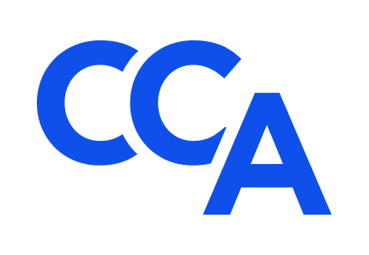
College of Commercial Arbitrators
Application for 2024-2026 Associates Mentorship Program
Submission Deadline (Extended): March 29, 2024
Applicant.
Name: ______________________________________________________________________
Employer: ___________________________________________________________________
Occupation: _________________________________ Title: __________________________
Address: ____________________________________________________________________
Email: ______________________________________ Phone: ________________________
Please submit the following information to support your application for the third annual CCA Associates Mentorship Program (Program) as outlined in the accompanying Invitation: (1) a concise letter from you to the CCA Standing Committee on Diversity, which explains (a) nature and extent of your prior experience serving as an arbitrator, mediator, special master, or administrative hearing officer in domestic and/or international commercial dispute resolution proceedings prior to and during the past five years, (b) your reasons for applying or reapplying to participate in the Program, and (c) how you intend to develop the skills needed to distinguish yourself in the field of commercial arbitration; and (2) a concise resume of your education, training, and experience that highlights your credentials and qualifications for the Program, areas of subject matter expertise, and likelihood of your future success as a commercial arbitrator. Qualified non-attorneys are welcome to participate in the Program.
Two letters of recommendation in support of this application from Fellows or other ADR professionals with personal knowledge of your credentials, qualifications, character, talents, professionalism, and career goals are required.
Schedule of Events.
Application Submission Deadline (Extended): March 29, 2024.
Applicant Interviews: April 3 and 4, 2024.
Associate Selection Announcement: May 17, 2024.
Mentor Selection Announcement: June 14, 2024.
Initial Virtual Meeting of Associates and Mentors: September 9 – September 13, 2024 (TBD).
Second Virtual Meeting of Associates and Mentors: October 7 – October 11, 2024 (TBD).
CCA’s 24th Annual Meeting: October 24-26, 2024. Fellows and Associates only at Park Hyatt Aviara Resort in Carlsbad, CA.
CCA’s 25th Annual Meeting: October 23-25, 2025. Fellows and Associates only at Silverado Resort & Spa in Napa, CA.
Fellows, Mentors, and Associates will communicate regularly between annual meetings via bi-monthly Program meetings, periodic CCA committee meetings and events, and the CCA listserv, and they will collaborate informally throughout the year with the view towards sharing professional experiences, business development ideas, and professional networks in a collegial manner that promotes a rewarding career in commercial arbitration.
Affirmation.
Applicant affirms that (A) all information submitted in support of your application is true, accurate, and complete to the best of your knowledge, information, and belief; (B) you are ready, willing, and able to attend CCA’s 24th and 25th Annual Meetings in person (via the Tuition Waiver described in the accompanying Invitation) and actively participate in the Schedule of Events and other related CCA events; (C) you are not currently and have not previously been the subject of a professional disciplinary proceeding of any sort; and (D) it is your responsibility to promptly notify CCA and your Mentor in the event any of these circumstances change during your participation in this application process and Program.
Application Requirements.
Complete application packets, including letters of reference, must be submitted electronically to the Associates Mentorship Program Co-Chairs, L. Tyrone Holt at Ty.Holt@holtllc.com and Gene Commander at gene@genecommanderinc.com on or before the submission deadline with a copy to Bill Seward at info@ccarbitrators.org.

Signature: __________________________ Date: _____________________________

